Well, you’re very late!
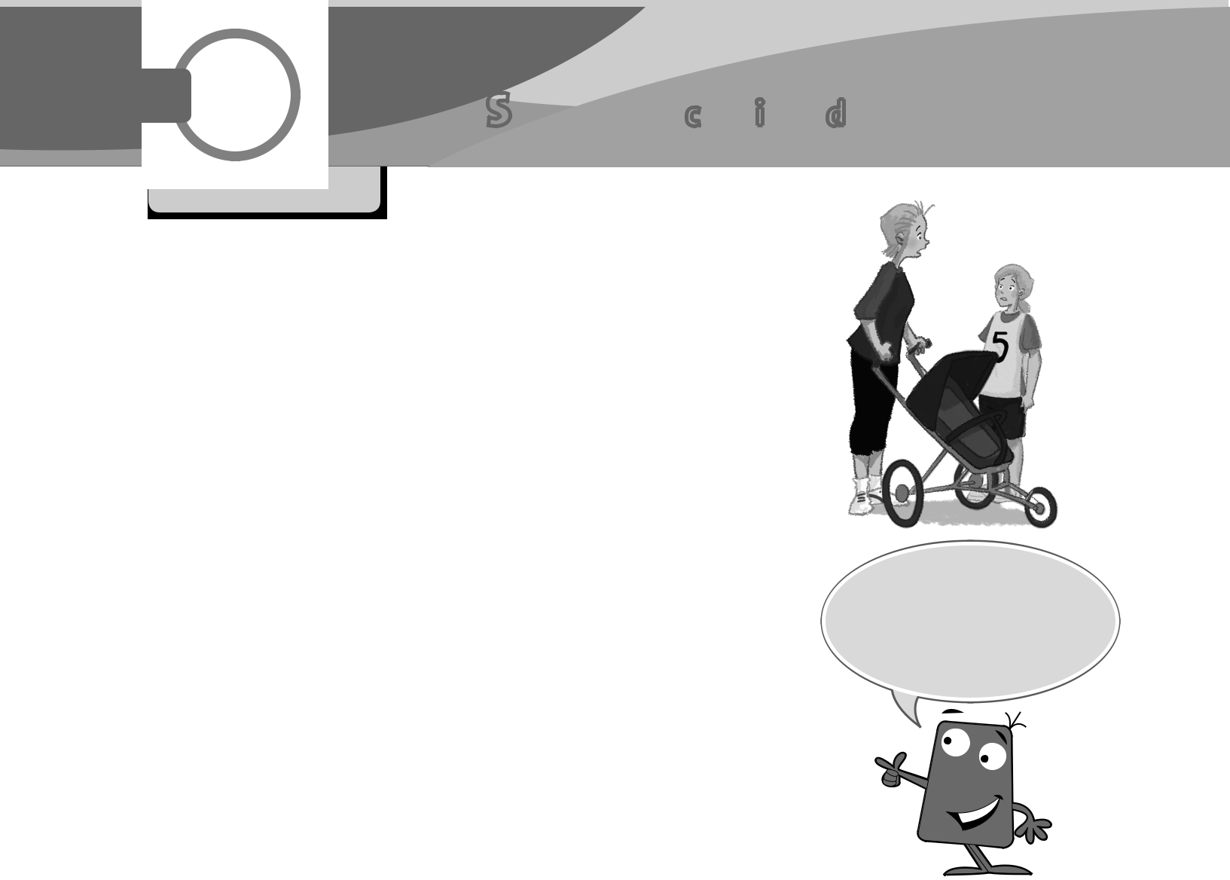  CYLET | Unit 6 Sports day
Flyers

1

Conversation

Listen and read. Then act.  28

Mrs Brown: Hello, Holly. So who do you think is going to win the 200-metre race?

Holly: The race has finished! George has already won!

Mrs Brown: Oh dear! Never mind! Did you see the volleyball match?

Holly: It hasn’t started yet. It starts at three o’clock.

Mrs Brown: Oh good! What time’s the football match?

Holly: The football match has just started, Mum!

Mrs Brown: Oh no!

Holly:

Mrs Brown: I know … I’m sorry. I couldn’t find my house key.

Holly: Oh no, not again, Mum!

Mrs Brown: Yes, and now I’ve lost my car key!

Look! Use ‘already’ for something that has happened or been done.

2

Make sentences. Match them with the pictures.
1 has / Mrs Brown / the school / just / at / arrived / | f
Mrs Brown has just arrived at the school. | f

- made / cakes / The parents / already / snacks / and / have

- just / The teachers / tidied / the classrooms / have

- flags / the playground / put / already / in / have / The children

- have / their tickets / paid / The parents / already / for

- prizes / hasn’t / The head teacher / yet / the children / their / given
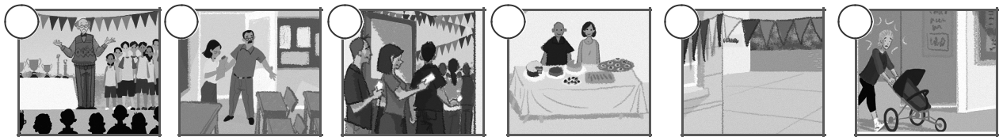

a | b | c | d | e | f


Family and Friends Special Edition Grade 5 | 1 | © Oxford University Press
Expansion Portfolio Unit 6 | 1 | Permission granted to reproduce for instructional use.

CYLET

Flyers

Listening

3 Listen to the head teacher. He’s talking to the children and parents about sports day. Write the missing information. 29
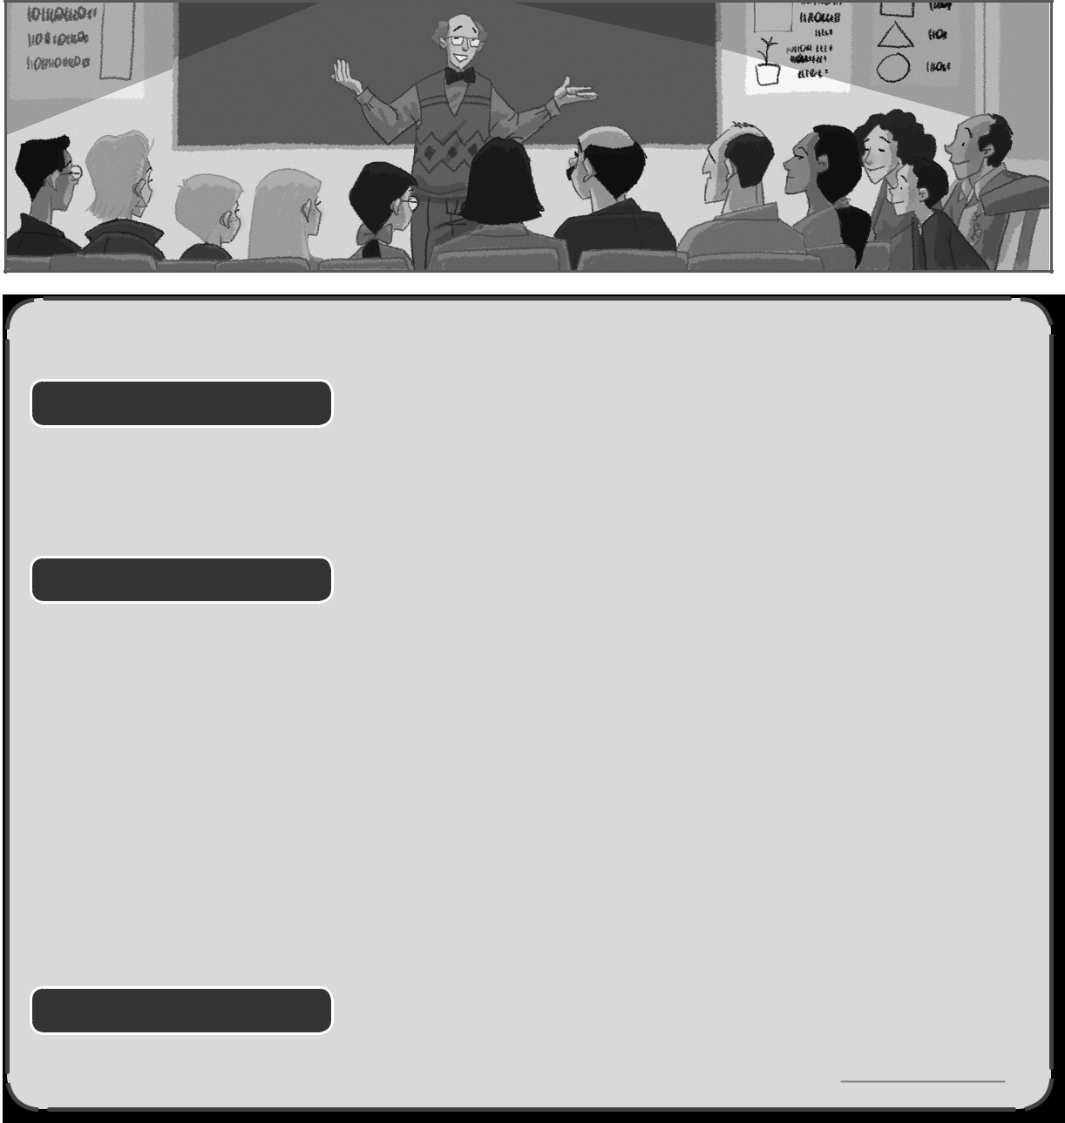

21ST JUNE PRIZE WINNERS!

200-metre race |  |  |  |  | Example
winner: |  |  |  |  |  | George
prize for being (1) |  |  | : |  | Harry
Football match
first half score: |  |  |  |  | 2 / 1
score at end of match: |  |  |  |  | (2)
winning team: |  |  |  |  | the (3)
Volleyball match
score at end of match: |  |  |  |  | (4)
winning team: |  |  |  |  | the (5)
Money!

Money from sports day is for the school camping (6)

4 Now make sentences about sports day.


 | Katy |  |  |  |  |  | has |  |  | made |  |  |  |  |  |  | a wonderful day.
 |  |  |  |  |  |  |  |  |  | won |  |  |  |  |  |  | the 200-metre race.
 | Harry
 |  |  |  |  |  |  | have
 |  |  |  |  |  |  |  |  |  | heard |  |  |  |  |  |  | some lovely cakes and snacks.
 | The school
 |  |  |  |  |  |  |  |  |  | seen |  |  |  |  |  |  | very brave.
 | We
 |  |  |  |  |  |  |  |  |  | had |  |  |  |  |  |  | some great matches.
 | George
 |  |  |  |  |  |  |  |  |  | eaten |  |  |  |  |  |  | the high jump competition.
 | I
 | I |  |  |  |  |  |  |  |  | been |  |  |  |  |  |  | over £300.
Family and Friends Special Edition Grade 5 |  |  |  |  |  |  |  |  |  |  |  |  |  |  | 2 |  | over £300.
 |  |  |  |  |  |  |  |  |  |  |  |  |  |  | 2 |  |  |  |  |  | © Oxford University Press
Expansion Portfolio Unit 6 |  |  |  |  |  |  |  |  |  |  |  |  |  |  | 2 |  | Permission granted to reproduce for instructional use.


CYLET Flyers

Writing & speaking

5. Katy has written about the 200-metre race for the school magazine. Write the missing words in the sentences. Then number the pictures in the correct order.


hurt went smiled waved waited gave held won fell began ran came


1 The boys and girls went

to the starting line and waited for the race to

begin.

2 The sports teacher

her flag and the

race .

- During the race, Harry and
himself but he

was very brave.
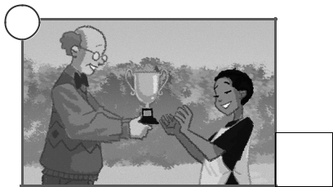

4 George across

the finishing line first and the race.
- The head teacher

George a prize because he first in the race.
6 George |  |  | up the
silver cup and |  |  |  |  | at
his parents.
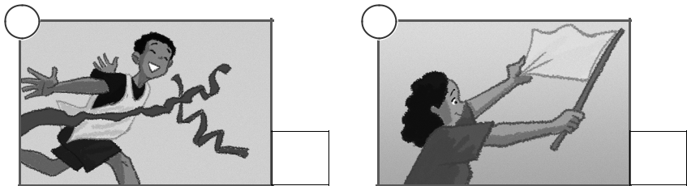

a | b | c
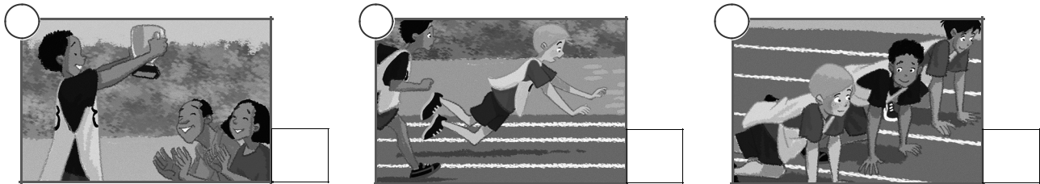

d | e | f

1

Family and Friends Special Edition Grade 5 | 3 | © Oxford University Press
Expansion Portfolio Unit 6 | 3 | Permission granted to reproduce for instructional use.

CYLET

Flyers

Mini-test


istening, Part 1

6Listen and draw lines. There is one example. |  |  |  |  |  |  | 30
Daisy Michael |  |  |  |  |  | Fred |  |  | Mary
Richard |  | Jim |  |  |  |  |  |  | Sally
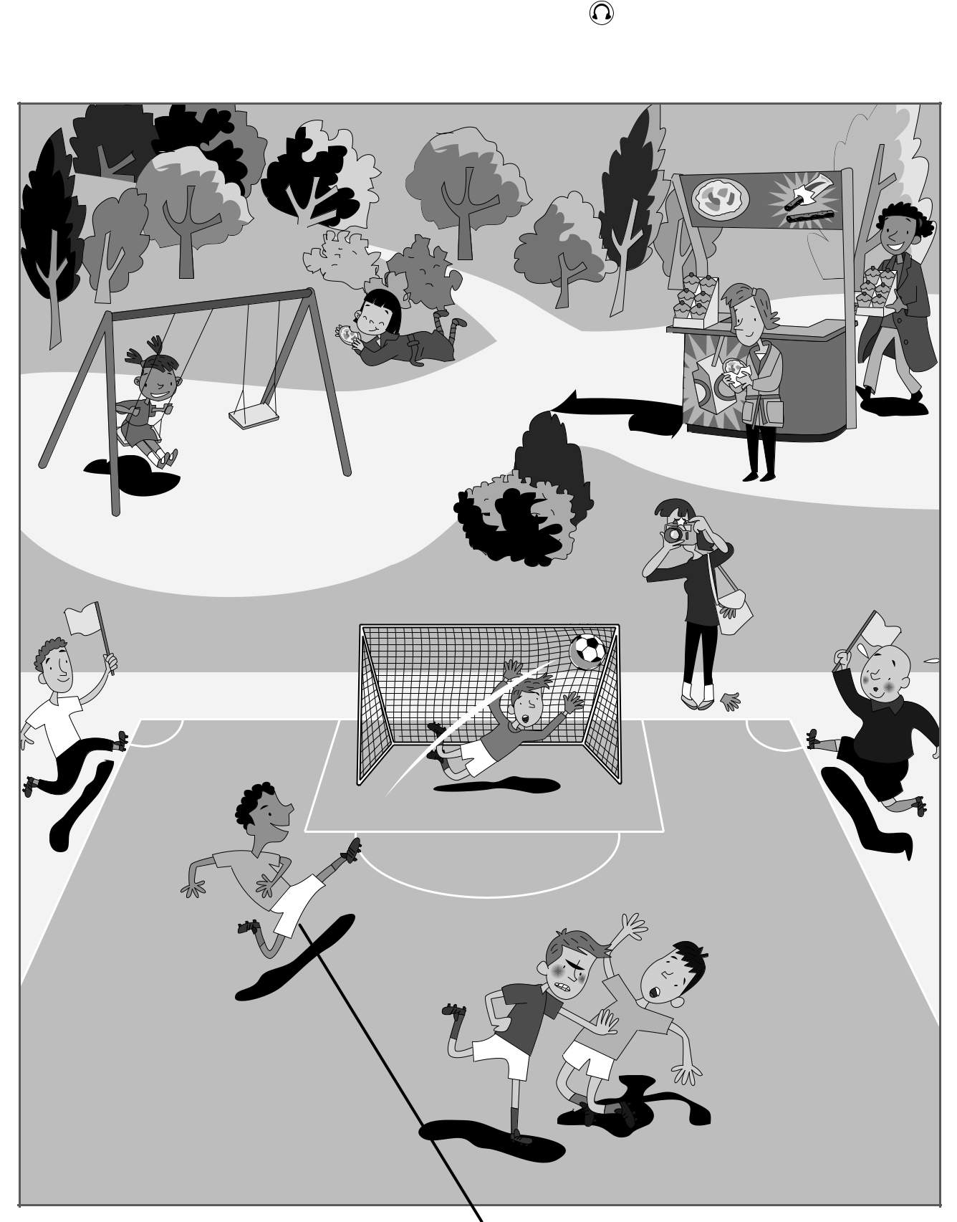

Family and Friends Special Edition Grade 5 | 4 | © Oxford University Press
Expansion Portfolio Unit 6 | 4 | Permission granted to reproduce for instructional use.

CYLET

Flyers

Mini-test

7ading & Writing, Part 5

7 .Look at the picture and read the story. Write some words to complete the sentences about the story. You can use 1, 2, 3 or 4 words.


Sports day at school

Hello! I’m Holly and Harry’s Mum and I had a very busy morning! It was sports day at the children’s school. My other daughter, Emma, is only two so she hasn’t started school yet. I decided to take her with me to see the older children doing their sports. We were leaving the house when Emma remembered her new doll. She wanted to take it with her and she was crying. I put my keys down and went into Emma’s bedroom. It was really untidy! I found the doll in the end. It was under a blanket. Emma smiled happily when I gave it to her.

We were ready to go. I looked for my keys but I couldn’t find them anywhere. Then Emma pointed at the shelf in the dining room and there they were next to the envelopes. I don’t know how they got there. We left the house and walked to the school quickly. When we arrived, we saw my daughter, Holly. She didn’t say ‘hello’ to us and she was a bit unfriendly, actually. She told me I was really late.

I missed the children’s race but I did see the volleyball match. That was very funny because during the game a dog went onto the field and ran away with the ball! All the children were trying to catch the dog! The dog was very excited and thought it was a wonderful game. Round and round the children ran! The head teacher looked very unhappy about it! ‘Whose dog is that?’ he shouted angrily! And he didn’t talk about the dog when he gave the children their prizes! But I thought it was a wonderful afternoon! Holly plays for a team called the Sharks and they won, so she was happy too in the end.

Family and Friends Special Edition Grade 5 | 5 | © Oxford University Press
Expansion Portfolio Unit 6 | 5 | Permission granted to reproduce for instructional use.

CYLET

Flyers

Mini-test
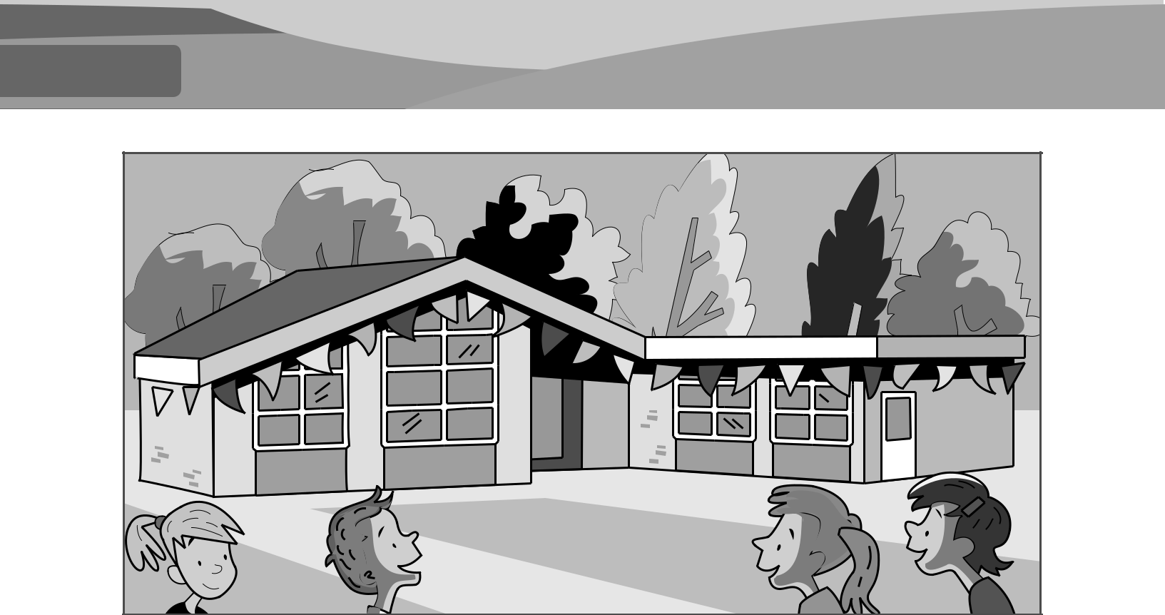

Examples

Betty Brown was very busy this morning.

At her children’s school it was sports day .

Questions
1 | Betty’s daughter, Emma |  |  |  | school yet.
2 | Emma wanted to take her |  |  |  |  | to the school.
3 | Betty found what Emma wanted |  |  |  |  |  | in the bedroom.

- Betty’s keys were in the dining room on a shelf near the

.

- Holly wasn’t happy with her mum because her mum got to school very

.

- During the volleyball match, a dog took the children’s

 |  |  |  | .
7 | The head teacher was |  |  |  |  |  | when the children ran
 | af ter the dog.
8 | Betty had a lovely |  |  |  |  | .

Family and Friends Special Edition Grade 5 | 6 | © Oxford University Press
Expansion Portfolio Unit 6 | 6 | Permission granted to reproduce for instructional use.

CYLET

Flyers

8 Look at the pictures. Write the names of the jobs in the boxes.
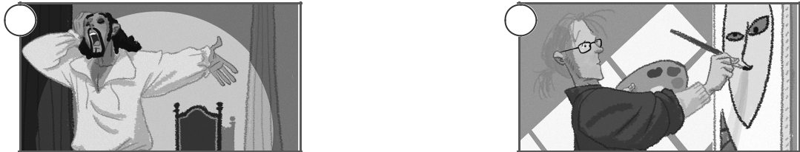

1 | 2

a c t o r
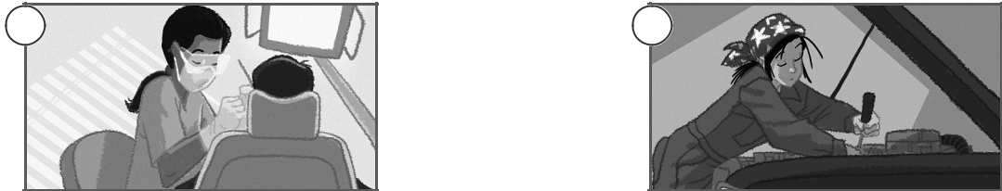

3 | 4

9 Draw lines to find the words that start with ‘ex’.

Read the sentences and write. Then colour.


 |  |  |  |  | sive |  |  |  |  |  |  |  |  |  |  |  |  |  | ci |  |  |  |  |  | pl
 |  |  |  |  |  |  |  |  |  |  |  | am |  |  |  |  |  |  | ci |  |  |  |  |  |  |  |  |  |  |  |  |  | ted
 |  |  |  |  |  |  |  |  |  |  |  |  |  |  |  |  |  |  |  |  | ex
 |  |  |  |  |  |  |  |  |  |  |  |  |  |  |  |  |  |  |  |  | ex |  |  |  |  |  |  |  |  |  |  |  |  |  |  |  | lent
 |  | ct |  |  |  |  |  |  |  |  |  |  |  | tin |  |  |  |  |  |  | ex |  |  |  |  |  |  | a |  |  |  |  |  |  |  |  | lent
 |  |  |  |  |  |  |  |  |  |  |  | pen |  |  |  |  |  |  | cel |  |  |  |  |  |  |  |  |  |  |  |  | ain
 |  |  |  |  | ple |  |  |  |  |  |  |  |  |  |  |  |  |  | cel |  |  |  |  | m

- This is the one that shows you what to do. example (grey)

2 | Dinosaurs are now |  |  |  |  | . (orange)
3 | You often do this test at the end of the school year. |  |  |  |  |  |  |  |  |  |  |  |  | (red)
4 | Really, really good work! |  |  |  |  |  | ! (purple)
5 | You feel like this before you go on a trip. |  |  |  |  |  |  |  |  |  | (brown)
6 | Not cheap. |  |  | (green)
7 | If you don’t understand your teacher will do this. |  |  |  |  |  |  |  |  |  |  |  | (pink)

Family and Friends Special Edition Grade 5 | 7 | © Oxford University Press
Expansion Portfolio Unit 6 | 7 | Permission granted to reproduce for instructional use.

^{CYLET} Review

Flyers

10 Match the pictures with the sentences and add the question tags.
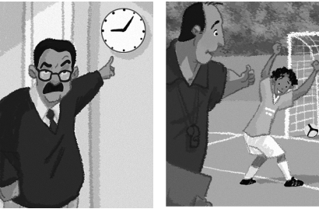
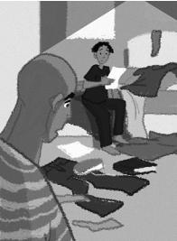

 |  |  |  |  |  | 1
1 | Tony’s very good at football, |  |  |  |  |  |  |  |  |  |  |  | isn’t he ? |  |  |  |  |  |  |  |  | are you?
2 | You’re late again, |  |  |  |  |  |  |  |  |  |  |  | ? |  |  |  |  |  |  |  |  | isn’t he?
 |  |  |  |  |  |  |  |  |  |  |  |  |  |  |  |  |  |  |  |  |  | can’t I?
3 | You aren’t very well, |  |  |  |  |  |  |  |  |  |  |  | ?
 |  |  |  |  |  |  |  |  |  |  |  |  |  |  |  |  |  |  |  |  |  | doesn’t she?
4 | Your bedroom isn’t very tidy, |  |  |  |  |  |  |  |  |  |  |  | ?
5 | Helen looks very pretty, |  |  |  |  |  |  |  |  |  |  |  |  |  |  | ? |  |  |  |  |  | is it?
6 | I can read well, |  |  |  |  |  |  |  |  |  |  | ? |  |  |  |  |  |  |  |  |  | aren’t you?

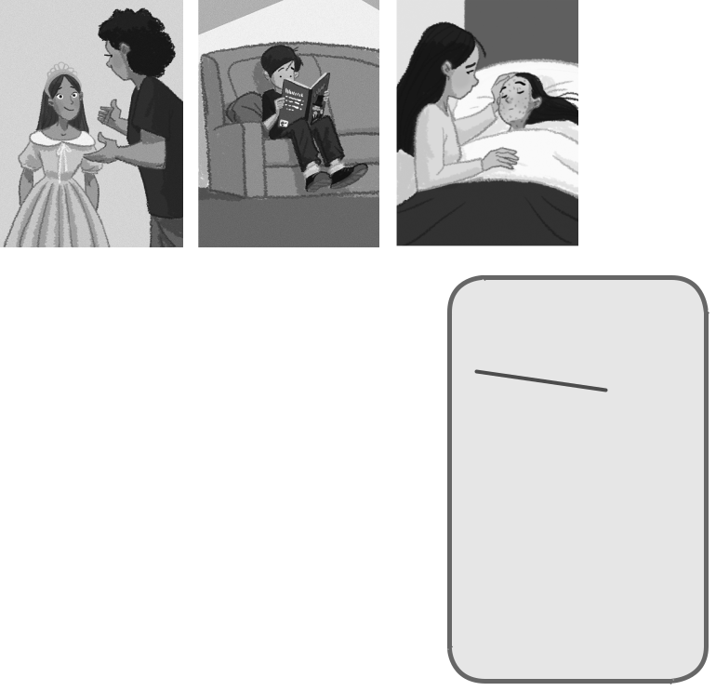

11 Read the story and write the missing words.
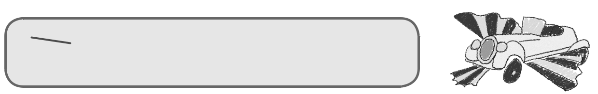

saw was drive go went fly were flying driving made flew living

Hello. My name’s Tony. Last week I (1) |  |  |  |  |  |  |  |  |  |  |  |  |  |  |  |  |  | saw |  |  |  | a really great film
when I (2) |  |  |  |  |  |  |  |  |  | to the cinema with my friends. It was about
a kind man who lived in an unusual house with his two children. They
(3) |  |  |  |  |  |  | very poor but the man (4) |  |  |  |  |  |  |  |  |  |  |  |  |  |  |  |  | an engineer
and he (5) |  |  |  |  |  |  |  |  |  | lots of exciting things for them. One day
he bought a really old car and he worked hard to repair it
and make it special for his children. When it was ready he decided to
(6) |  |  |  |  |  |  | the car to a beach for a picnic. He took his children
with him and they were (7) |  |  |  |  |  |  |  |  |  |  |  |  |  |  |  |  |  | up a road though the hills
when the car suddenly (8) |  |  |  |  |  |  |  |  |  |  |  |  |  |  |  |  | into the air. It had large red
and yellow wings and it could (9) |  |  |  |  |  |  |  |  |  |  |  |  |  |  |  |  |  |  |  |  | ! The children couldn’t
believe it! They were (10) |  |  |  |  |  |  |  |  |  |  |  |  |  |  |  | like birds, high up in the sky!
After a few hours they arrived at a strange castle. A very unfriendly
man was (11) |  |  |  |  |  |  |  |  |  |  |  |  | in the castle and he tried to steal their
wonderful car. Then their adventure really began. If you want to know
what happened next, you’ll have to (12) |  |  |  |  |  |  |  |  |  |  |  |  |  |  |  |  |  |  |  |  |  |  | and see the film.

